SMALLEST NUMBER IN AN ARRAY

# EXP NO: 09

## AIM:

To find the smallest number from an array using 8085 Processor.

ALGORITHM:  
 1. Load the address of the first element of the array in HL pair.  
 2. Move the count to B register.  
 3. Increment the pointer.  
 4. Get the first data in A register.

5. Decrement the count.  
 6. Increment the pointer.  
 7. Compare the content of memory addressed by HL pair with that of A register.  
 8. If carry=1, go to step 10 or if carry=0 go to step 9  
 9.  Move the content of memory addressed by HL to A register.  
 10.  Decrement the count.

PROGRAM:  
 LXI H,2000  
 MOV C,M  
 DCR C  
 INX H  
 MOV A,M  
 LOOP1: INX H  
 CMP M  
 JC LOOP  
 MOV A,M  
 LOOP: DCR C  
 JNZ LOOP1  
 STA 2008  
 HLT

## INPUT:

## 

## OUTPUT:

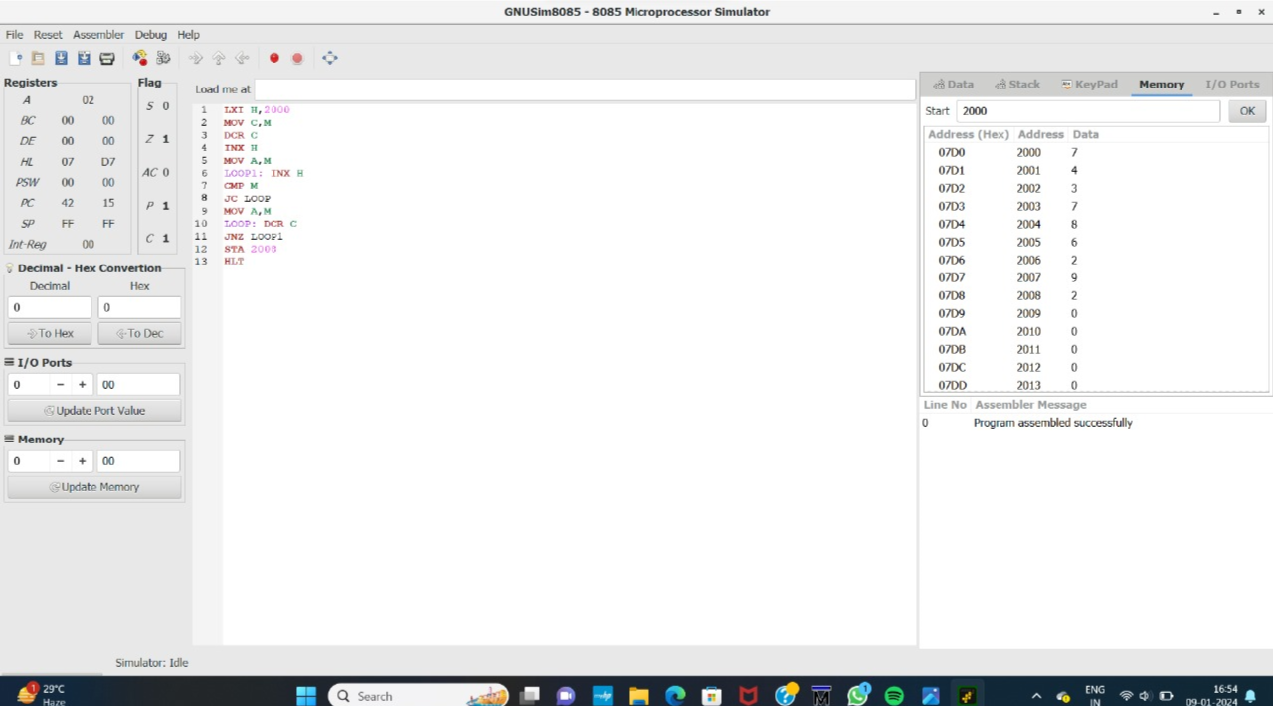

## RESULT:

Thus the program was executed successfully using 8085 Processor.